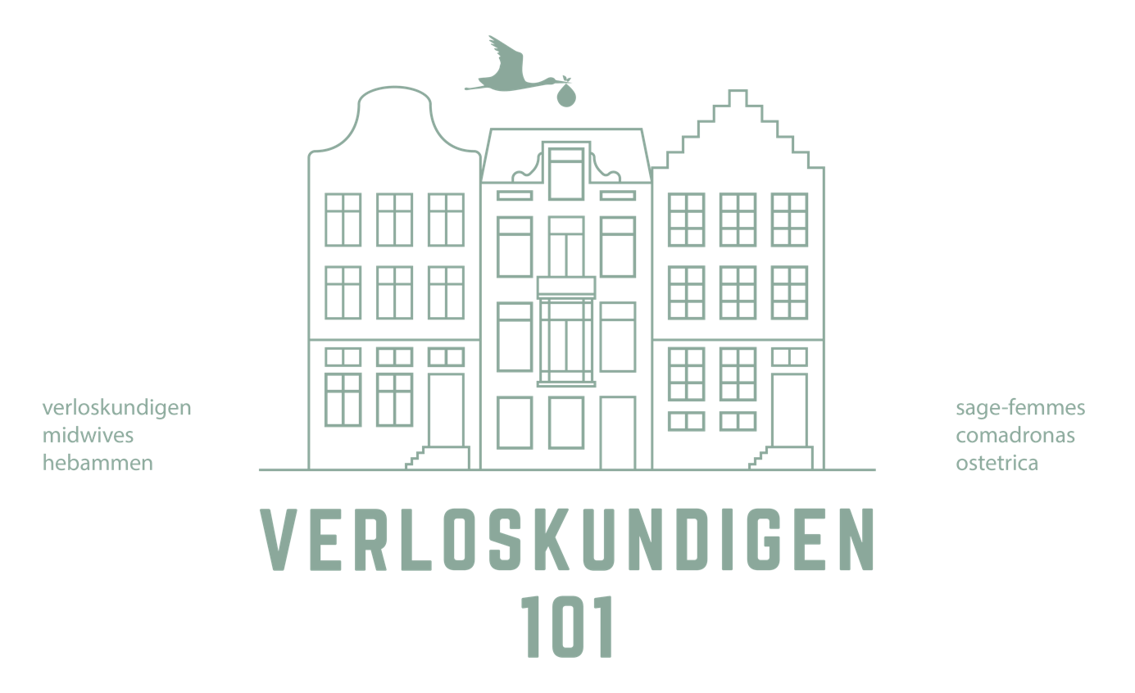

Birth wishes
of
...............................................

We see it as a privilege to be able to guide your labour & birth. We are there for you from the moment you need it. With patience and trust, being quiet at times as well as talking you through. We are actively present and can withdraw into the background when necessary. Doing nothing and intervening. All this and more is the role of us midwives, also known as “watchful attendance”. Our goal is a safe delivery for both mama and baby and a positive birth experience. Your birth can be at home or in the hospital, with or without pain relief.
We are there for you.

What to expect from your midwives:

IN GENERAL
Natural birth: We believe that your body can give birth and therefor strive for a natural birth. As long as you and the baby are doing well, there is no rush.
Peaceful environment: We help you create a peaceful environment, whether you are going to give birth at home, in the Birth Center or in the hospital. We have our “on call” phone with us, of course, but will leave the room whenever possible when the phone rings.
Positive approach: We use positive language and take your preferences into account.
Shared decision making: We will always consult with you if we want to do an examination or see a reason to go to the hospital. If you like it, we'll leave you alone to make a choice. In an emergency situation we will always inform you but act quickly.

INTERVENTIONS
Internal examination: We only perform internal examinations with your permission (we will explain the reason for this beforehand). In order to monitor the progress of the delivery, we will regularly suggest tot do an internal examination during the dilation phase. It differs per labour how often this is needed.
Breaking membranes: We only break the membranes with your explicit permission and after an explanation of why we would like to do this. We can also wait for the membranes to break on their own.
Equipment: We use the doptone to monitor the baby's heartbeat. During the dilation we do this with every home visit and during the pushing phase just about after every contraction.
Pain relief: We sometimes propose this on our own if we see a reason to do so, will inform you well and of course listen to you if you ask.
(Press) contractions: We can help you adopt different positions during the different phases of labour. If we think it is beneficial to the process, we will suggest a change of attitude. You choose in which position you want to give birth.
Perineum: We rarely cut. This is usually only necessary when the baby appears to be in distress or during an art delivery.
AFTER BIRTH
Baby: If one of you wants to handle the baby, we'll help. We then place the baby on the mother's breast. This is a pleasant place for the baby to relax, no matter what kind of food you want to give the baby. We dry the baby a bit, but don't rub the sebum away. We always offer to give vitamin K, by mouth, after delivery. You choose whether you want that.
Time: After the birth we always leave you alone for a while to land together. We respect the golden hour after birth in which you get to know each other and then leave you alone as much as possible. We weigh and examine the baby afterward.
Breastfeeding: If you want to breastfeed, we will help you on your way after the birth. We give the baby time to search for itself.
Umbilical cord: We have the umbilical cord knocked out. You choose by whom and when the umbilical cord is cut. If you would like to use a cord ring instead of an umbilical cord, you will have to buy it yourself, as only the Birth Center has this standard.
Placenta: We do not give a standard oxytocin shot. If there are reasons to do so, we will always communicate that to you.
Sometimes something happens during the delivery that makes us worry about you or the baby. Then we may want to deviate from what we have described above. We always do this with explanation and we will never do anything without your permission.

Surroundings
Where would you prefer to give birth?
..........................................................................................................................................
What kind of ambiance would you like to have in the room where you will give birth? What is necessary to achieve this?
..........................................................................................................................................
..........................................................................................................................................
Are all practical things arranged (babysitter for the older children, transportation)?
..........................................................................................................................................

What would you like to have on camera? Who will make the photo’s?
..........................................................................................................................................

Preparation
Did you follow a pregnancy course? If yes, which one?
..........................................................................................................................................

With what emotion do you look at birth?
What makes that you feel that way?
..........................................................................................................................................
..........................................................................................................................................
..........................................................................................................................................
What do you think you need to be able to give birth?
..........................................................................................................................................
..........................................................................................................................................
..........................................................................................................................................
If we would need to refer your care to the hospital staff, what would be important for you to be mentioned?
..........................................................................................................................................
..........................................................................................................................................
What are looking forward most to?
..........................................................................................................................................
..........................................................................................................................................

Guidance
What do you expect from your (birth)partner?
..........................................................................................................................................
..........................................................................................................................................
Are there other people present at birth? What are your expectations from them?
..........................................................................................................................................
..........................................................................................................................................
What are your expectations of the midwife (or if necessary the hospital doctor/midwife/gysnaecologist)?
..........................................................................................................................................
..........................................................................................................................................
Whats your opnion on vaginal internal examination?
..........................................................................................................................................
..........................................................................................................................................
What are your expectations of the kraamzorg (or hospital nurse)?
..........................................................................................................................................

Communication
What type of communication style would you prefer during labour and birth?
Would you prefer shared decision making or rather not? What suits you?
..........................................................................................................................................
..........................................................................................................................................

Dealing with the pain

How sensitive are you to pain and how do you respond to pain ususally?
..........................................................................................................................................
..........................................................................................................................................
What can help you to deal with the pain?
..........................................................................................................................................
..........................................................................................................................................
..........................................................................................................................................
Whats your vision on pain relief?
..........................................................................................................................................
..........................................................................................................................................

Birth
Would you or your birth partner like to catch the baby at birth?
..........................................................................................................................................
..........................................................................................................................................
In which position would you like to push?
..........................................................................................................................................
..........................................................................................................................................
Are there other things important to you during the birth of the baby?
..........................................................................................................................................
..........................................................................................................................................
..........................................................................................................................................

After birth

Who will cut het cord?
..........................................................................................................................................
What would you like to do with the placenta?
..........................................................................................................................................
What do find important in the first hour after birth?
..........................................................................................................................................
..........................................................................................................................................
..........................................................................................................................................
What is important to you concerning the first (breast)feeding moment of your baby?
What kind of help would you prefer to receive?
..........................................................................................................................................
..........................................................................................................................................
..........................................................................................................................................
Are there other things you would like to mention that are important for you after birth?
..........................................................................................................................................
..........................................................................................................................................
..................................................................................................................................

